21-21 CYCLING CHALLENGE 2082:

A GLOBAL MOVEMENT TO CELEBRATE NEPALI NEW YEAR
Cycle Connect Bhaktapur is once again bringing an exciting cycling initiative to mark Nepali New Year 2082 – the 21-21 Cycling Challenge! This challenge is designed to motivate individuals to embrace cycling, adopt healthier habits, and connect with their communities while celebrating the rich heritage of Nepal on a global scale.

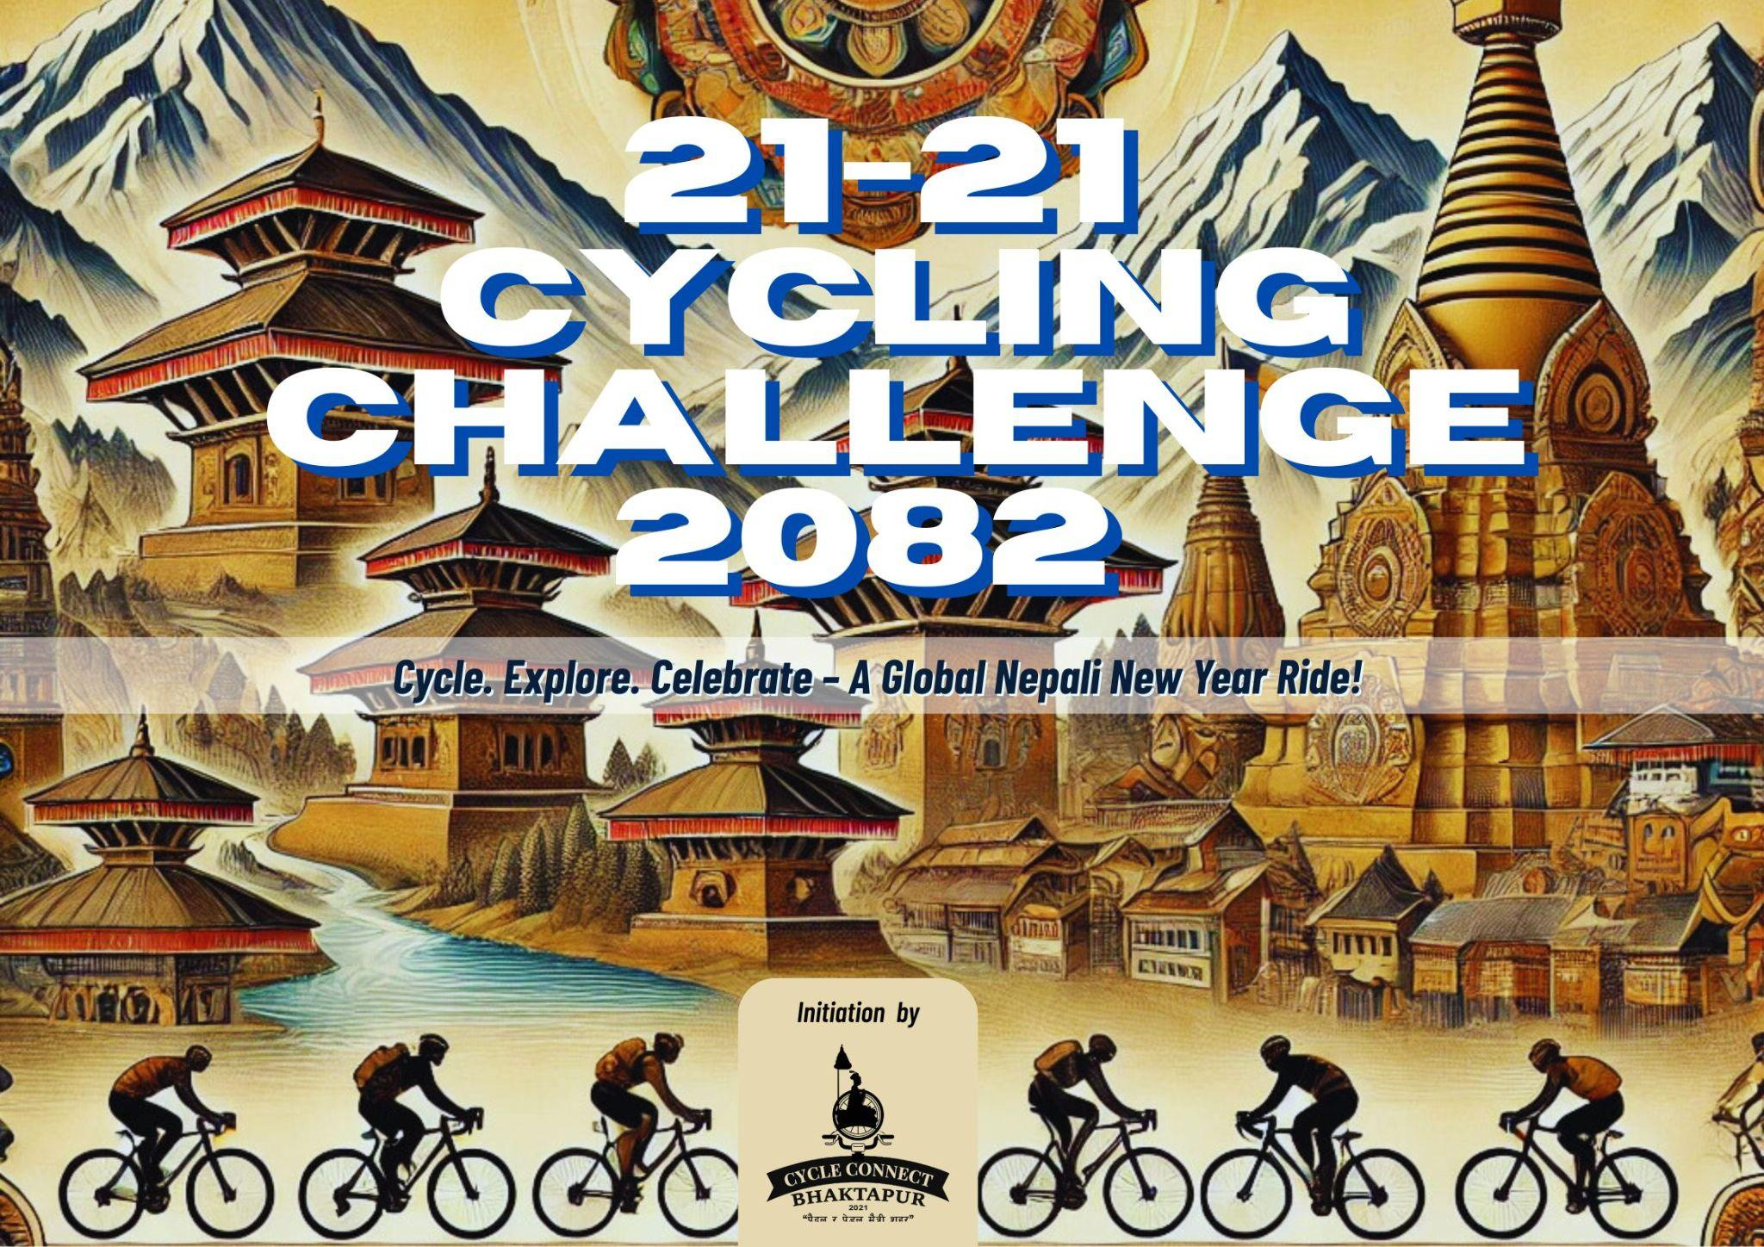

🌟 About Cycle Connect Bhaktapur
Cycle Connect Bhaktapur is an active community of cycling enthusiasts committed to promoting a pedestrian- and pedal-friendly city. Since its inception as a hobby group, it has grown into a movement that organizes innovative cycling events and advocacy programs with a strong commitment to sustainability and community engagement.
After its establishment in 2021, Cycle Connect Bhaktapur has been organising several cycling events and programs, including the widely celebrated Kora Challenge and the annual 21 Days Cycling Challenge held on Baishakh 1 each year. This event was first launched in 2079 (2022) and has become an annual tradition, inspiring cyclists to take on the challenge of riding for 21 days straight, reaching 21 different destinations.

🚴‍♂️ What is the 21-21 Cycling Challenge?
The 21-21 Cycling Challenge is a 21-day commitment to cycling, where participants ride to 21 different destinations starting from Baishakh 1, 2082 (April 14, 2025), to Baishakh 21 (May 4, 2025).
Initially, the challenge had a more competitive format, but this year, it has been expanded to encourage more participation worldwide. The focus is not just on endurance but also on making cycling a daily habit, exploring local destinations, and promoting sustainable mobility.

🌍 A Call to Nepalis Worldwide!
This year, Cycle Connect Bhaktapur aims to make this a truly global movement by inviting Nepali communities around the world to take part. If you are Nepali, it’s time to take the initiative! Organize the challenge in your city, connect with fellow riders, and celebrate Nepali New Year with a meaningful and healthy start!
From the culturally rich and cycle-friendly city of Bhaktapur to the vibrant streets of Kathmandu, Lalitpur, Dharan, Pokhara, Chitwan, Butwal, Nepalgunj, and Nepali communities in New York, London, Sydney, Tokyo, and beyond, let’s come together to make this a worldwide celebration of cycling, health, and Nepali heritage!

📍 How to Participate?
✅ Choose 21 local destinations that you can cycle to.
✅ Start on Baishakh 1 (April 14, 2025), and ride daily until Baishakh 21.
✅ Share your journey on social media using #2121CyclingChallenge to inspire others.
✅ Encourage your friends, family, and local Nepali communities to take part!

🔥 Why Take the Challenge?
🚴 Form a daily cycling habit – It takes 21 days to build a habit, and cycling is a great way to stay fit!
🎉 Celebrate Nepali New Year in an active, meaningful way.
🌏 Promote local cycling destinations in your city or town.
💚 Contribute to sustainability – Cycling reduces pollution and traffic congestion.
📈 Be part of a global movement – Connect with Nepali cyclists worldwide!

🌎 A Tradition Rooted in Sustainability
Cycling has always been at the heart of sustainable development, addressing issues like energy overconsumption, pollution, and urban mobility. This challenge aligns with the United Nations’ 11 Sustainable Development Goals (SDGs) and promotes a greener, healthier future.
Since its introduction, the 21 Days Cycling Challenge has evolved, bringing together thousands of cyclists to ride not just for fitness but also for personal growth and community well-being.

🚴‍♂️ Join the 21-21 Cycling Challenge & Be a Part of Something Bigger!
Cycle Connect Bhaktapur invites YOU to be part of this movement. Whether you are a seasoned cyclist or a beginner, this challenge is designed to push your limits, inspire you, and connect you with a larger cause. Let’s ride together, inspire each other, and make this the biggest cycling celebration yet!
🔗Initiated by: Cycle Connect Bhaktapur
📅 Challenge Duration: Baishakh 1 - Baishakh 21, 2082 (April 14 - May 4, 2025)
📍 Location: Anywhere in the world!
🚴‍♀️🌏 Cycle. Explore. Celebrate – A Global Nepali New Year Ride! 🌏🚴‍♂️
#2121CyclingChallenge #NepaliNewYearRide #CycleForHealth #GlobalCyclingChallenge #PedalIntoTheNewYear

